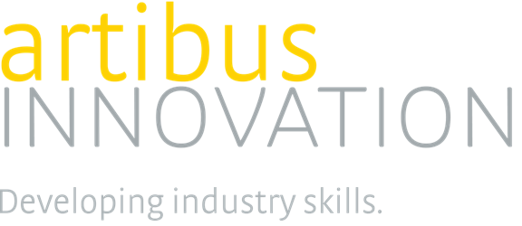

Project Brief 1 - Certificate III in Remote Area Building Repairs and Maintenance

Project Scope
The Construction, Plumbing and Services IRC is creating a national qualification, primarily for remote areas in Australia, by transitioning the Accredited Course 10391NAT Certificate III in Remote Area Building Repair and Maintenance into a national qualification housed in the CPC Training Package.

One new qualification is to be developed with the number of new units of competency to be developed to be advised.

Project Summary
This project will use, as a foundation, an accredited course to create a national qualification available for remote areas Australia wide. The majority of residents in remote communities throughout Australia are indigenous and some of the most disadvantaged job seekers. The aim of the Certificate III in Remote Area Repairs and Maintenance is to provide:

- meaningful training and a pathway from Certificate II level qualifications in building and construction
- context specific skills and knowledge for the repair, maintenance and asset protection of residential and commercial buildings in remote communities
- building of local workforce capacity and Indigenous participation in economic and employment opportunities.

The units and assessment requirements will be written to reflect cultural protocols and practices and industry expectations, and the Companion Volume Implementation Guide will be updated with additional information on this niche sector targeted at training providers and consumers.

Key points
Policy:

Transition the accredited course to a qualification which aligns with:

- Standards for Training Packages 2012
- COAG Industry and Skill Council directives

Regulations:

Review the accredited course and transition into a qualification that reflects current Workplace Health and Safety (WHS) standards, practice, protocols and procedures.

Consultation:

An IRC approved consultation process will be undertaken that will ensure all key stakeholders are consulted in this project.

